附件 1

**出口方和进口方共同声明**

Joint Declaration of the Exporter and the Importer

|  |  |  |  |  |
| --- | --- | --- | --- | --- |
| **产品名称** | **产品** | **中国质量标准名称或** | **进口国（地** | **生产厂商** |
| **（含规格、型号）**Product | **数量** | **国外质量标准名称** | **区）** | Producer |
| Name | Product | The Name of Quality | Importing |  |
| (including specifications | Quantity | Standards of China or | Country/Re |  |
| and model) |  | the Foreign Country | gion |  |
| JIU YOU 牌 MZJY01 型一次 | 686000 个 | GB/T 32610-2016 | 沙特阿拉伯 | **梅州市九酉** |
| 性使用口罩（非医用） |  |  |  | **医疗器械有** |
|  |  |  |  | **限公司** |
|  |  |  |  |  |

**出口方和进口方确认上述产品符合☑中国质量标准/ □国外质量标准（请勾选），且符合双方协议确定的产品质量标准。进口方保证协议确定的产品质量标准符合进口国（地区）对该产品的质量标准要求，并确认接受上述产品的质量标准。**

The exporter and the importer hereby confirm that the above products are compliant with the □quality standards of China/ □quality standards of foreign country (please tick the box) and the quality standards stipulated in the agreement between the parties. The importer shall guarantee the product quality standards stipulated by the agreement are compliant with the quality requirements of the importing country/region, and shall confirm it has accepted the quality standards of the above products.

**进口方承诺严格依照协议不将所购口罩用于医用用途，并提示第三方不可用于医用用途，如因进口方或第三方使用、维护、保管不当造成损失的，出口方、生产厂商不承担责任。**

The importer shall commit to strictly abide by the agreement and not use the face masks it purchases for medical purposes and to warn any third party against using the face masks for medical purposes. The exporter or the producer is not liable for any losses caused by the inappropriate use, maintenance or keeping of the face masks by the importer or any third party.

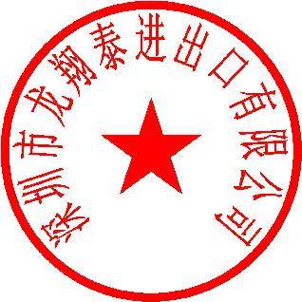

**本声明一式两份，双方各执一份。**

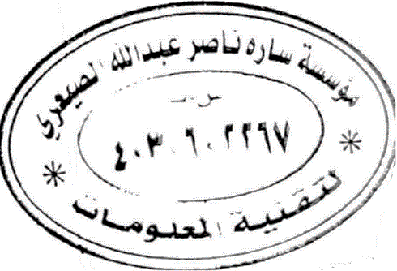This declaration is made in duplicate, one original for each party.

**特此声明。**

**出口方（盖章）** **进口方（签字）**

**出口方：深圳市龙翔泰进出口有限公司** **SARAH NASER ABDULLAHAL**

**SAARI EST**

**生产销售方：**梅州市九酉医疗器械有限公司

Exporter (Seal) Importer (Signature)

**2020年 5** **月29 日** **2020** **年** **5月 29日**